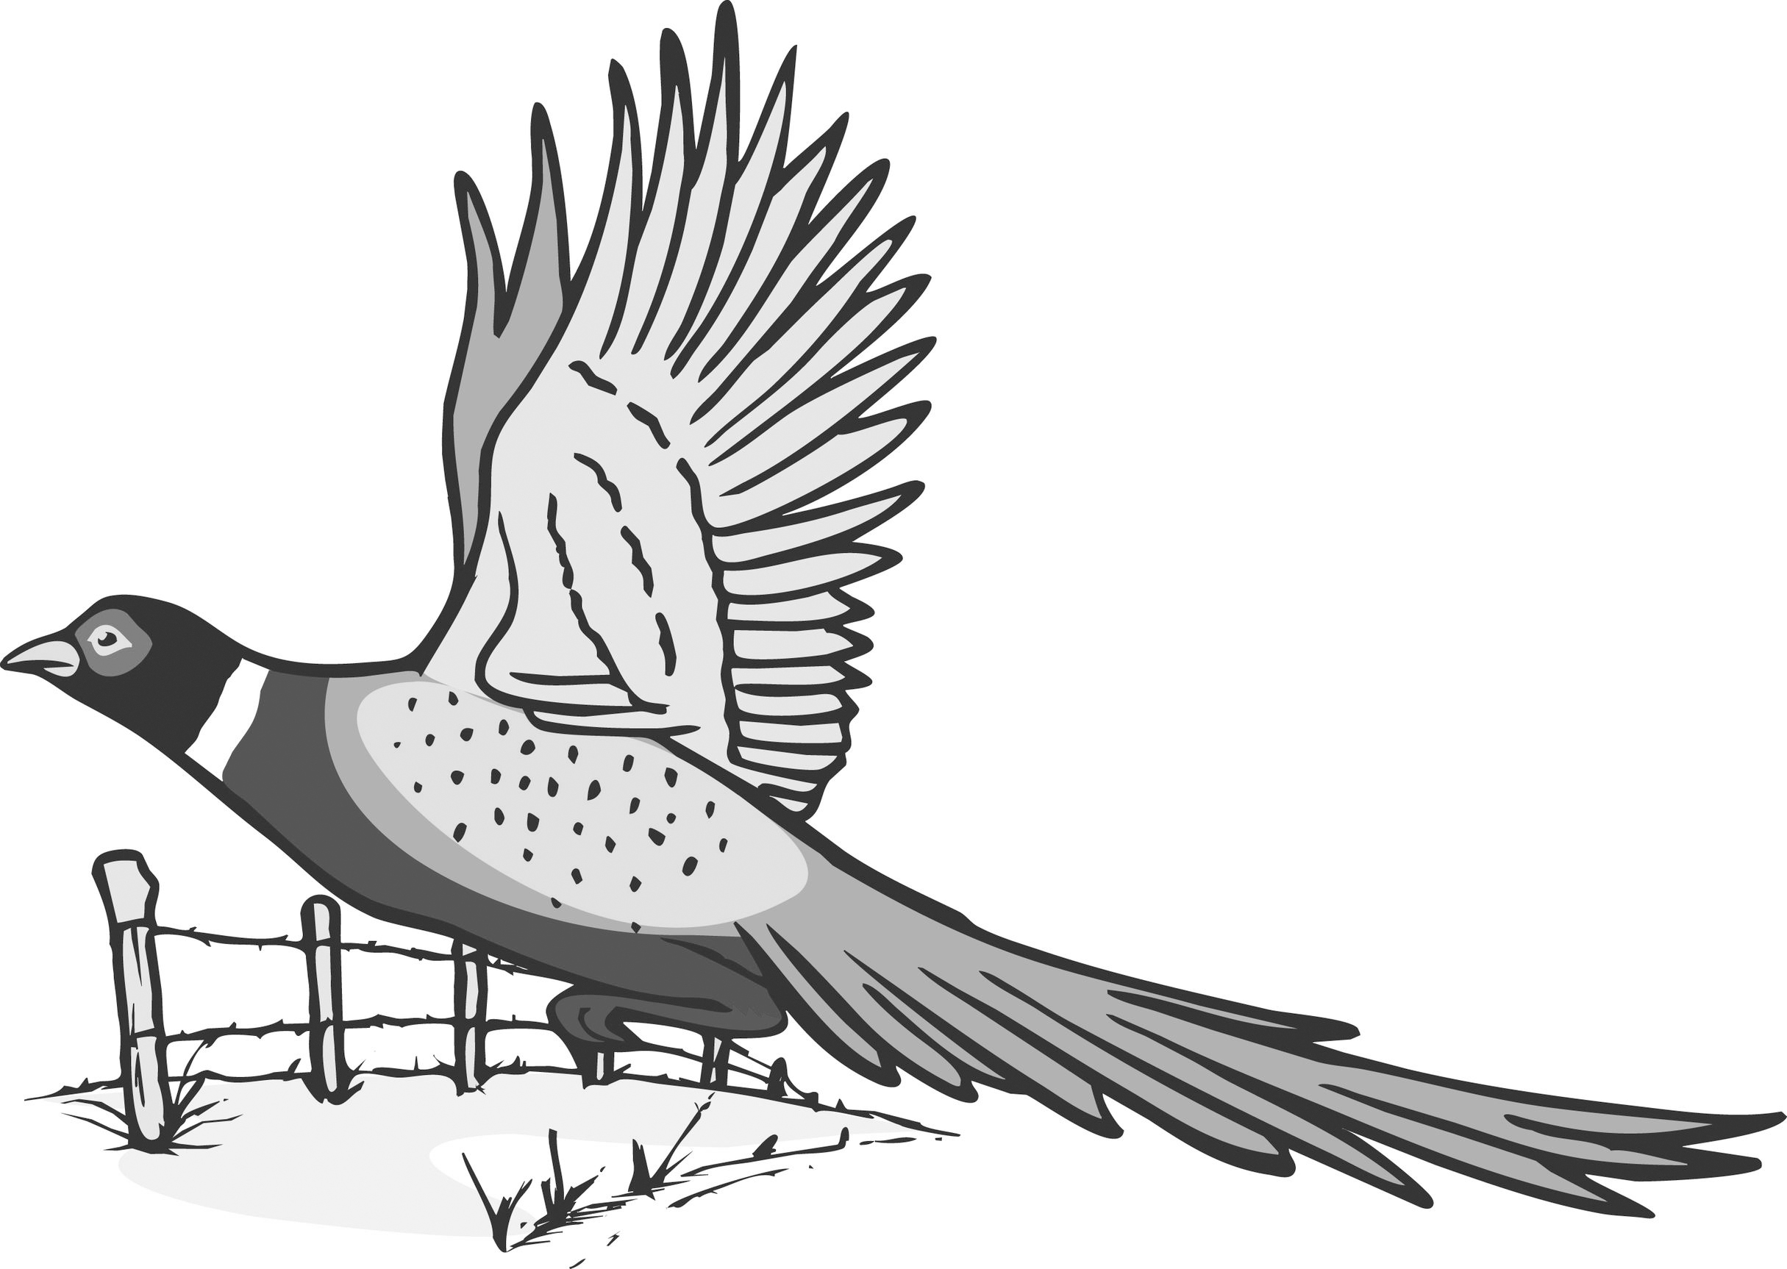

TRI-COUNTY SPORTSMEN CLUB
CLAYTON-DELAWARE-DUBUQUE
P.O Box 201 New Vienna, Iowa 52065
www.tricountysportsmen.com / tricountysportsmenclub@gmail.com

Camping Fees
Please send this form in with your fees.
$15.00 per night WITH electricity/water – $5.00 per night WITHOUT electricity

Name & Phone Number: ____________________________________________________

Address: _________________________________________________________________

Nights stayed: _____ x $15.00 $________
_____ x $5.00 $________

Thank you,
Tri County Board of Directors

TRI-COUNTY SPORTSMEN CLUB
CLAYTON-DELAWARE-DUBUQUE
P.O Box 201 New Vienna, Iowa 52065
www.tricountysportsmen.com / tricountysportsmenclub@gmail.com

Camping Fees
Please send this form in with your fees.
$15.00 per night WITH electricity/water – $5.00 per night WITHOUT electricity

Name & Phone Number: ____________________________________________________

Address: _________________________________________________________________

Nights stayed: _____ x $15.00 $________
_____ x $5.00 $________

Thank you,
Tri County Board of Directors

TRI-COUNTY SPORTSMEN CLUB
CLAYTON-DELAWARE-DUBUQUE
P.O Box 201 New Vienna, Iowa 52065
www.tricountysportsmen.com / tricountysportsmenclub@gmail.com

Camping Fees
Please send this form in with your fees.
$15.00 per night WITH electricity/water – $5.00 per night WITHOUT electricity

Name & Phone Number: ____________________________________________________

Address: _________________________________________________________________

Nights stayed: _____ x $15.00 $________
_____ x $5.00 $________

Thank you,
Tri County Board of Directors

