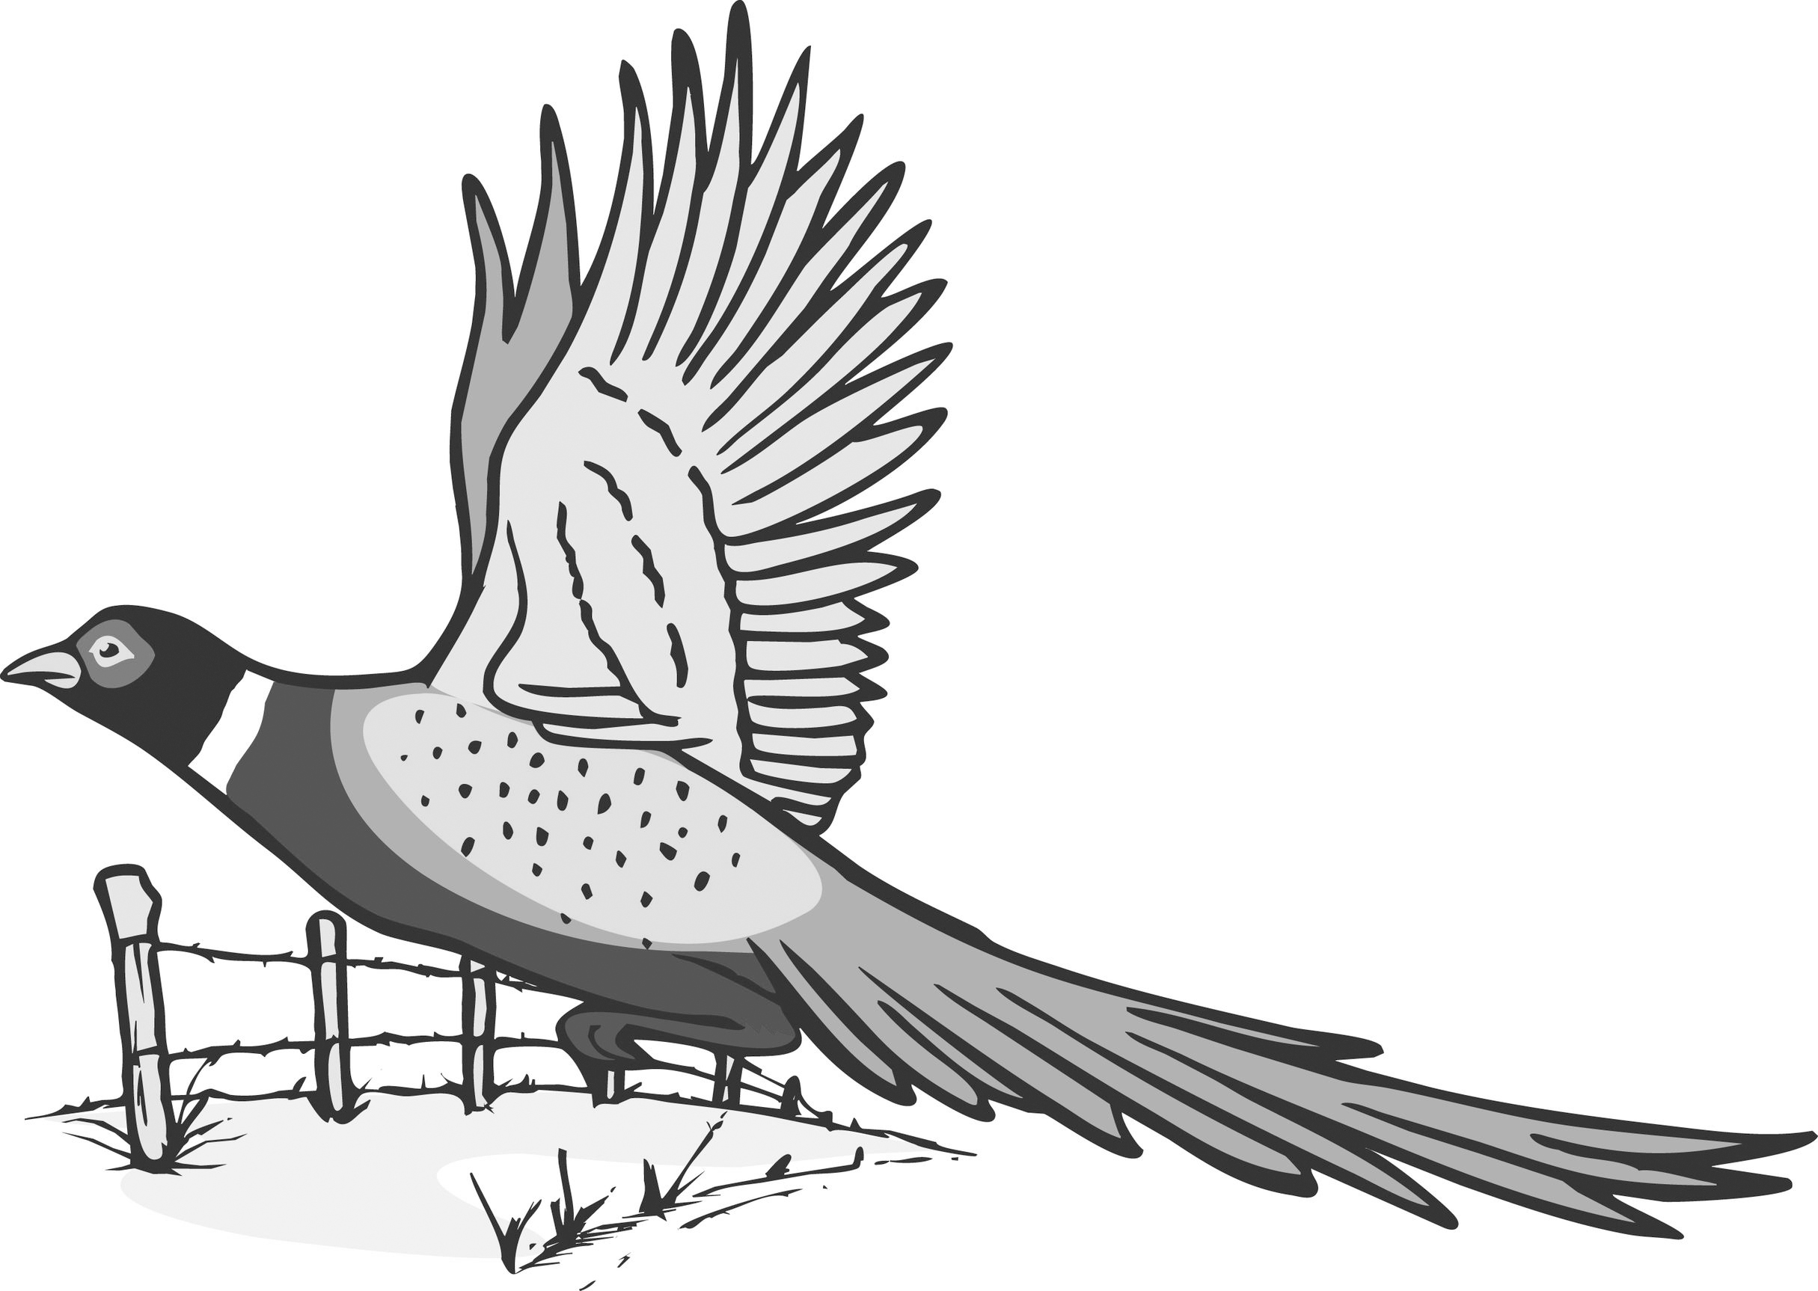
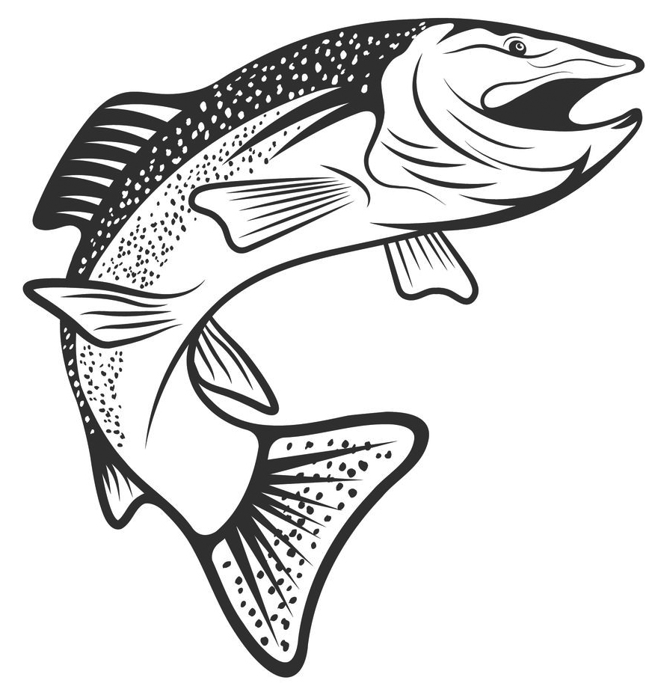
TRI-COUNTY SPORTSMEN CLUB
CLAYTON-DELAWARE-DUBUQUE
P.O Box 201 New Vienna, Iowa 52065
www.tricountysportsmen.com / tricountysportsmenclub@gmail.com

Tri-County Sportsmen Club Membership Form
Annual dues are $30 for new members and $25 for existing members. Memberships are due on January 1st of each year. Memberships are family memberships. Anyone over the age of 16 must purchase a membership in order to use the Tri-County Sportsmen Club property. Lifetime memberships are currently frozen until the board decides otherwise.
Shooting range key requires a separate application form – go to our website to download the range rules & application form.
Please fill out form below & return with payment to: Tri-County Sportsmen Club
P.O. Box 201
New Vienna, IA 52065
---------------------------------------------------------------------------------------------------------------------
☐ New Membership – $30 ☐ Renewal Membership – $25
*New members must also sign & return the Club’s Release & Waiver of Liability Agreement Form – go to our website to download the form.

Name: _____________________________________________
Address: ______________________________________________
City: _____________________ State: ___________ Zip: _________________
E-mail: __________________________________________________
Phone: _________________________
Cell: ___________________________
Optional: I would be willing to help at the following event(s) if available:

☐ Workdays at the property (Dates: TBD)
☐ Adopt-A-Hiway Cleanup – Apr & Sept
☐ Archery Shoot – July or August
☐ Rifle Range Maintenance (Dates: TBD)
☐ Trap Shoot – 1st Sunday in October
☐ Fish Fry – 1st Saturday in November
☐ Grass Mowing/Trimming

